


A guide to getting you started

Entry 2021

All students are to register with UCAS online, regardless of whether they are applying to go to university or not. The reason for this is that the UCAS application form doubles as a “snap shot” of their educational career which can be used as a resource for help with all types of application including Apprenticeships and Employment.

Step 1


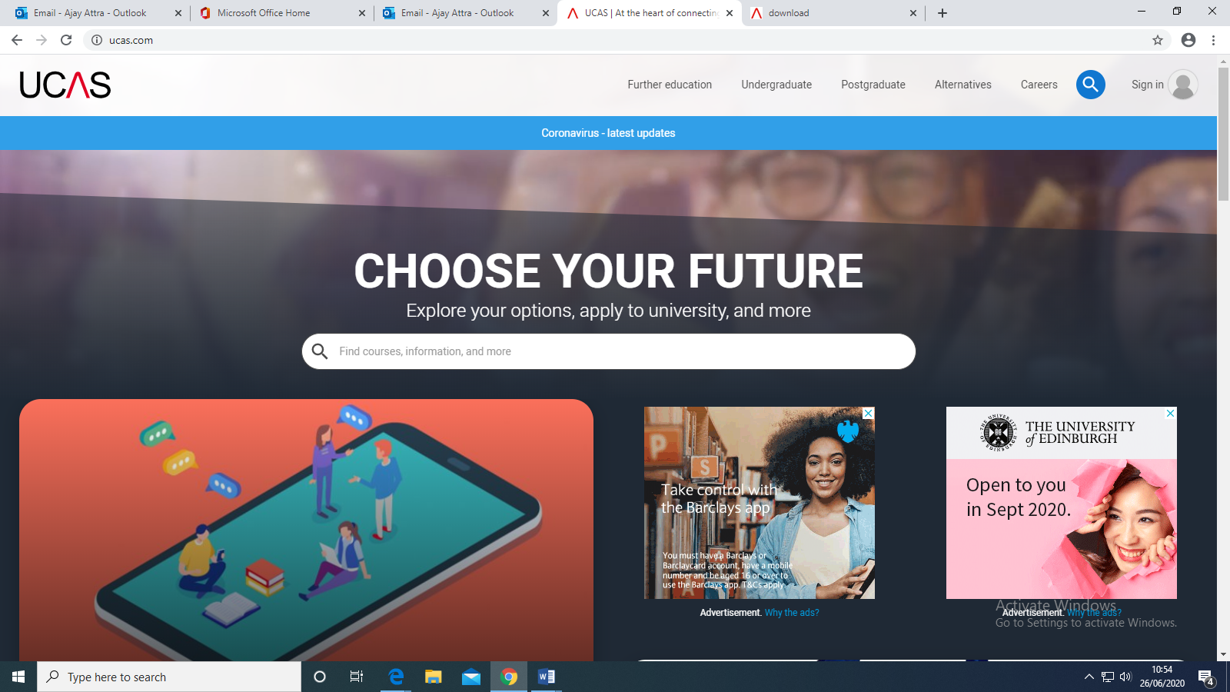
www.ucas.com
Click the sign in logo

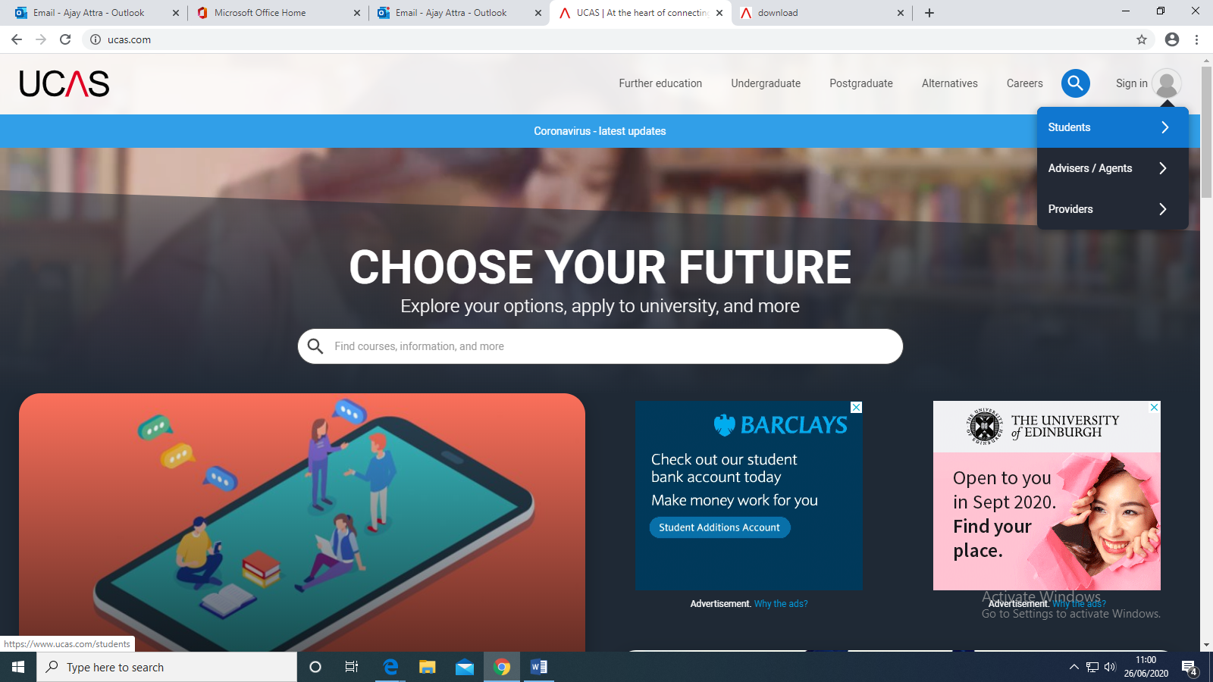
Select students

Step 2

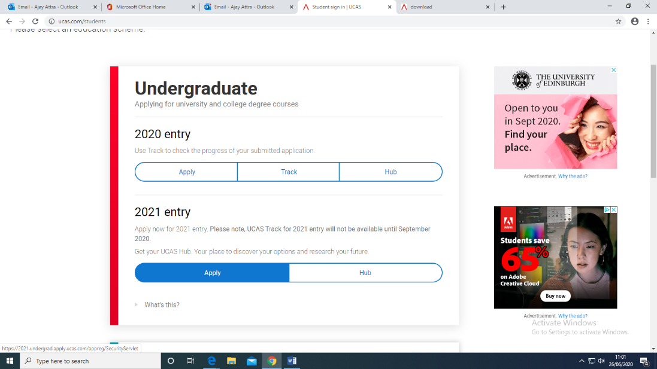
Select Undergraduate 2021 Entry Apply

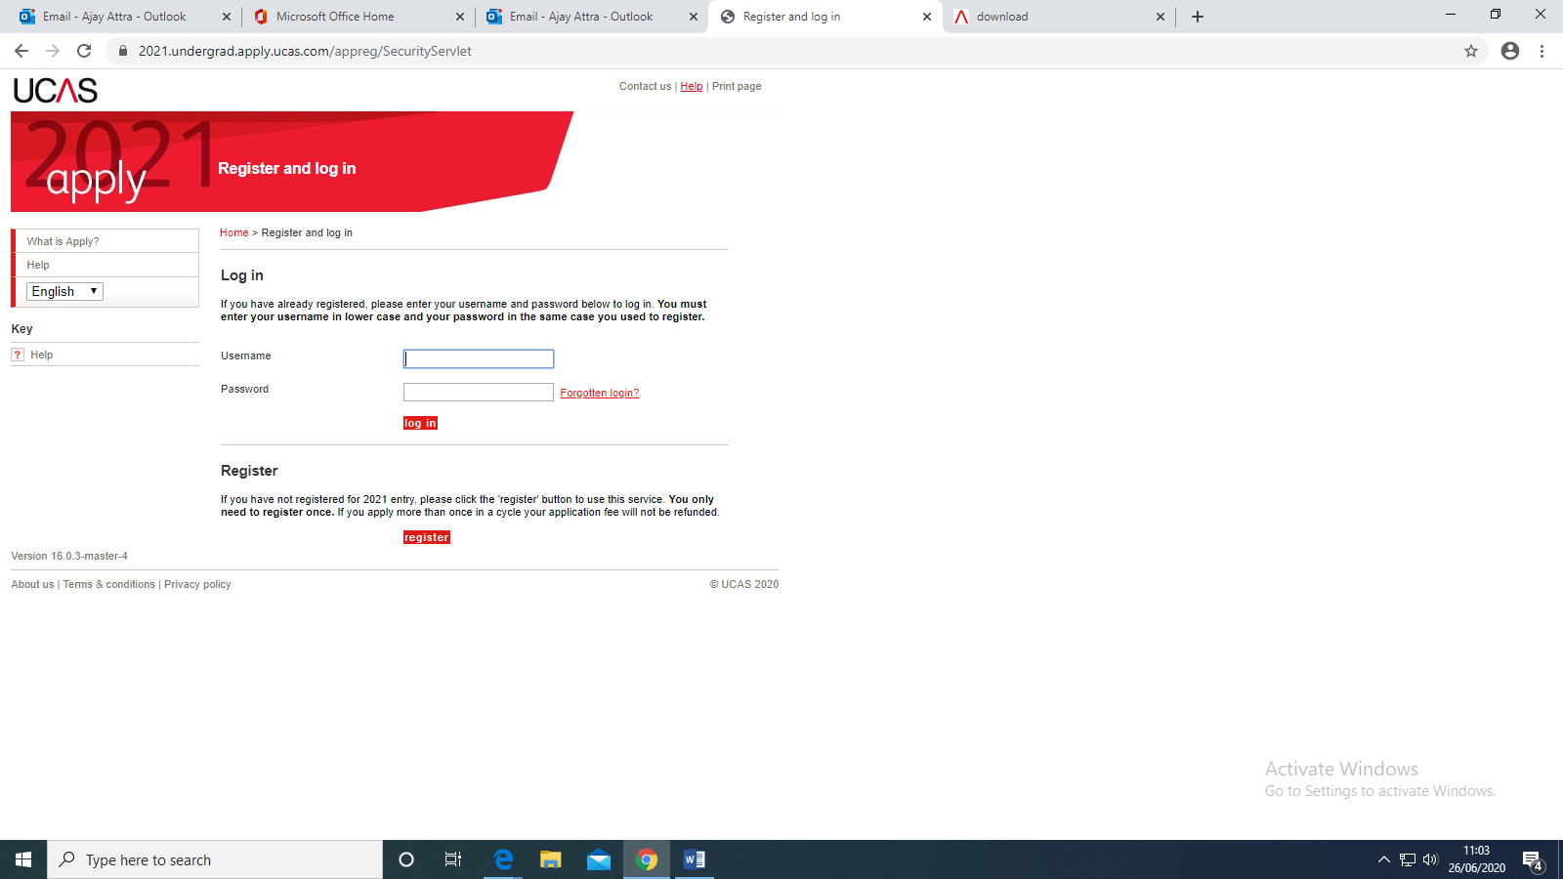
Select Register

Step 3
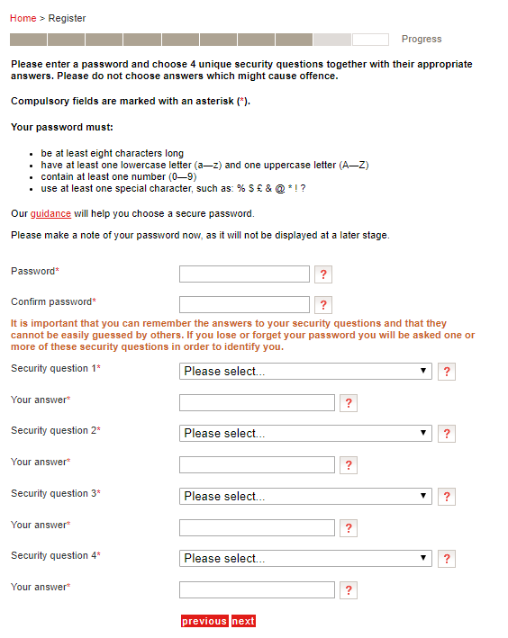
Now you will be asked to enter some personal details… Once completed you will be asked to enter a Password and enter some Security Questions.
PLEASE MAKE SURE YOU WRITE THE PASSWORD AND SECURITY QUESTIONS AND ANSWERS DOWN SOMEWHERE SAFE.
If You have any issues with a forgotten password, the security answers will help you gain access. We will not be in a position to help you if you forget your password.

Step 4
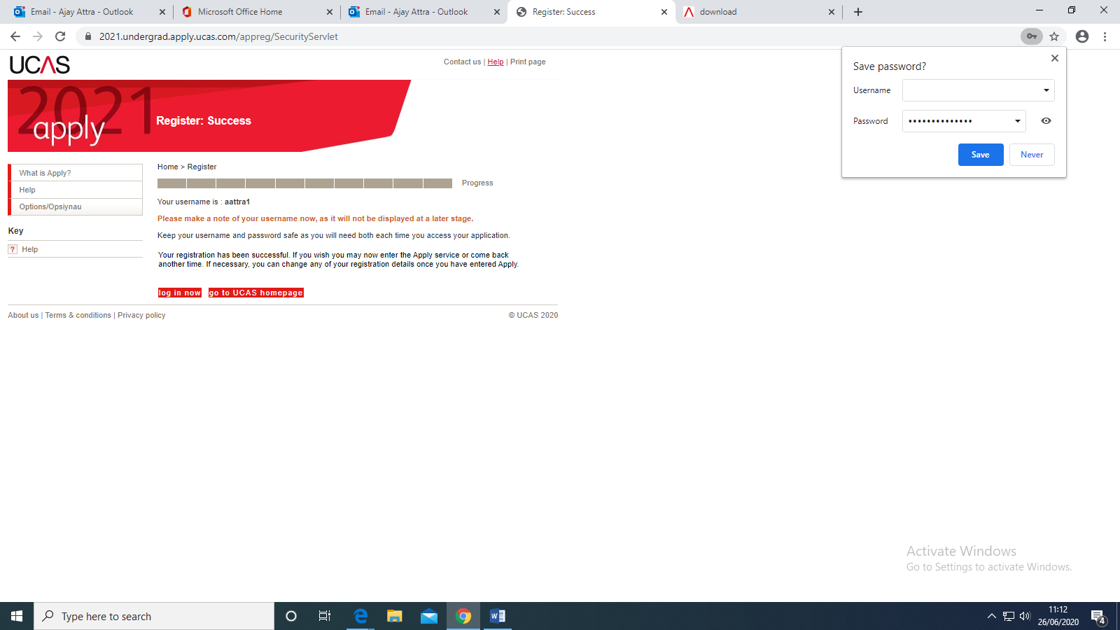
xxxxxxxxxxxxx
Make a note of your USERNAME and click LOG IN NOW…

Step 5
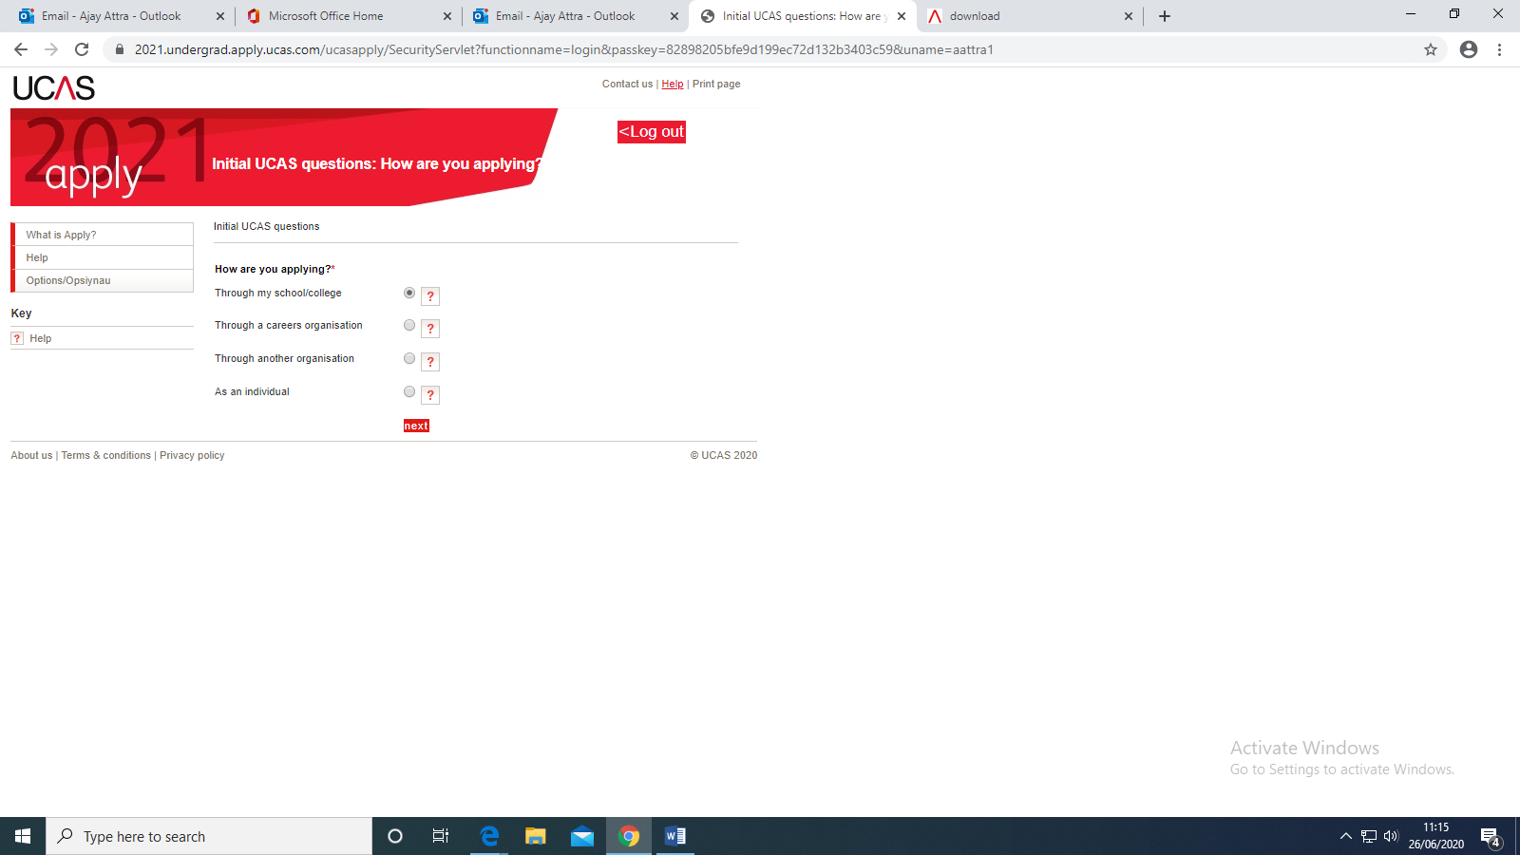
Select Through My School College

Step 6
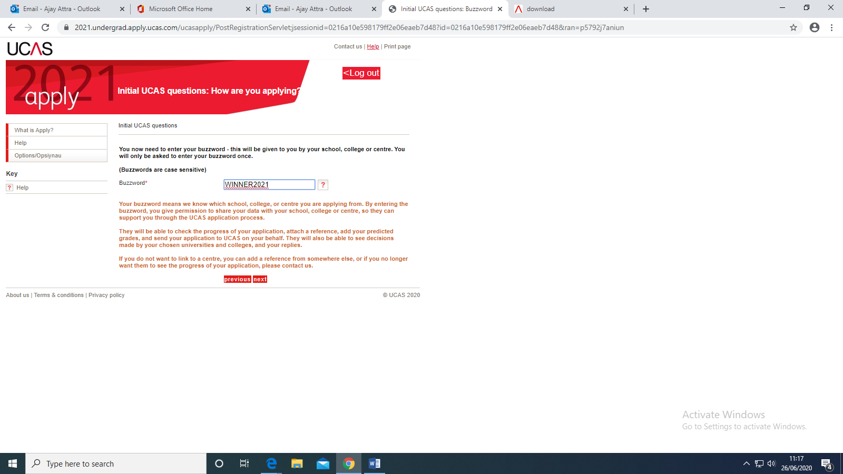
Type in the BUZZWORD which is WINNER2021

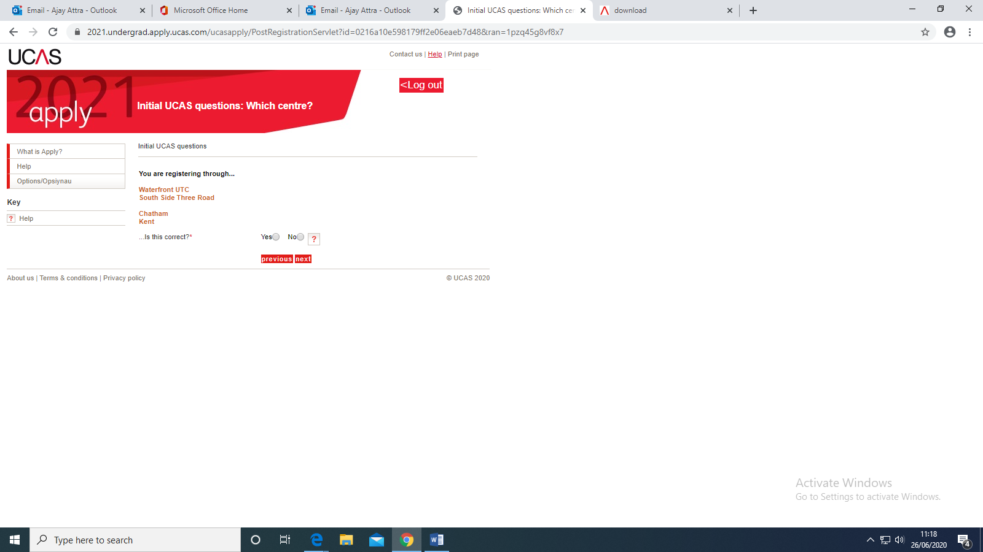
Step 7
Confirm you are registering through WaterfrontUTC

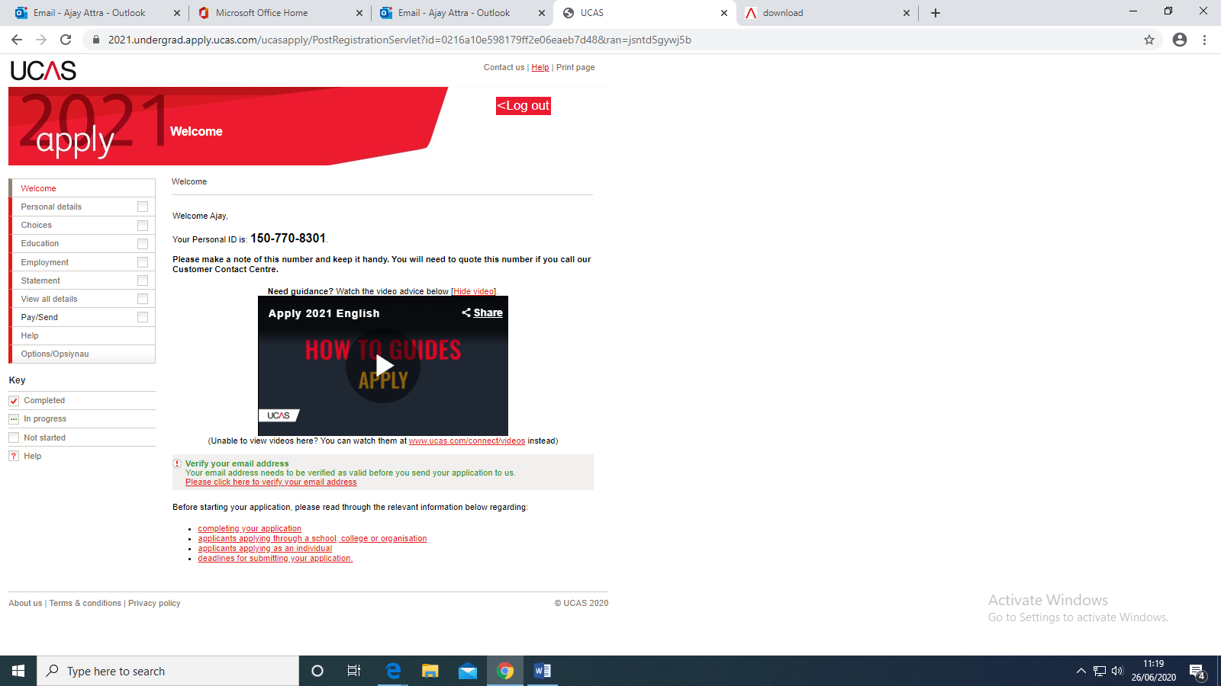
Step 8
MAKE A NOTE OF YOUR PERSONAL ID
XXXXXXX
XXXXXXX
Be sure to VERIFY your email address by logging in to your email and clicking the link
This is your online APPLICATION FORM. These are the different sections you need to complete

Work your way through the application form, filling in the different sections which are:
Personal Details: Mainly contact details for you and biographical data
Choices: The courses and the universities that you hope to study at
Education: Your GCSE’s and A Level subjects
Employment: Any part time work you have undertaken
Statement: Why you want to follow your chosen course

There are many guides available to help you complete the CHOICES and STATEMENT sections of the APPLICATION FORM, which we will be sending you.

If you require any additional help and advice you can contact Mr Attra or Mrs Taylor

a.attra@waterfront-that.org.uk

l.taylor@waterfront-that.org.uk

